* Trade Fixed Expense for variable expense – Advantage of cloud Computing
* **AWS Systems Manager** allows an organization to view operational data from multiple AWS services through a unified user interface and automate operational tasks
* **AWS Shield** is a managed Distributed Denial of Service (DDoS) protection service.
* Intelligent threat protection and monitoring – AWS GuardDuty
* Amazon Macie – Fully managed data security and data privacy service that uses ML and pattern matching to discover and protect your sensitive data in AWS
* **Amazon Detective** automatically collects log data from your AWS resources and uses machine learning, statistical analysis, and graph theory to build a linked set of data that enables you to easily conduct faster and more efficient security investigations - but does not actively detect threats.
* **AWS Cloud9 –** Cloud Based IDE
* **AWS Pricing Calculator –** Used to forecast costs
* **Amazon EC2** is billed on per second
* **Amazon Elasticache -** A database that supports reads with a latency of under a millisecond for critical applications.
* **Internet Gateway**is a AWS service or VPC component allows inbound traffic from the internet to access a VPC.
* **Virtual Private Gateway** is used for IPSec VPN connections to access a VPC
* A **NAT gateway** is used for outbound internet access for instances running in a private subnet
* **Amazon Cognito** lets you add user sign-up, sign-in, and access control to your web and mobile apps quickly and easily. Amazon Cognito scales to millions of users and supports sign-in with social identity providers, such as Apple, Facebook, Google, and Amazon, and enterprise identity providers via SAML 2.0 and OpenID Connect.
* **IAM** does not grant permissions to external third parties - only to internal AWS identity.
* **AWS Single Sign-On (AWS SSO)** is where you create, or connect, your workforce identities in AWS once and manage access centrally across your AWS organization. This does not allow users to login through a social identity provider.
* **AWS Sheild** and **Amazon CloudFront** are associated with Edge locations
* **AWS IAM Access Analyzer** helps you identify the resources in your organization and accounts, such as Amazon S3 buckets or IAM roles, shared with an external entity. This lets you identify unintended access to your resources and data, which is a security risk.
* **Amazon OpenSearch** Service makes it easy for you to perform interactive log analytics, real-time application monitoring, website search, and more
* **AWS Control Tower** provides the easiest way to set up and govern a secure, multi-account AWS environment, called a landing zone.
* **Amazon EventBridge** is a serverless event bus that makes it easier to build event-driven applications at scale using events generated from your applications.

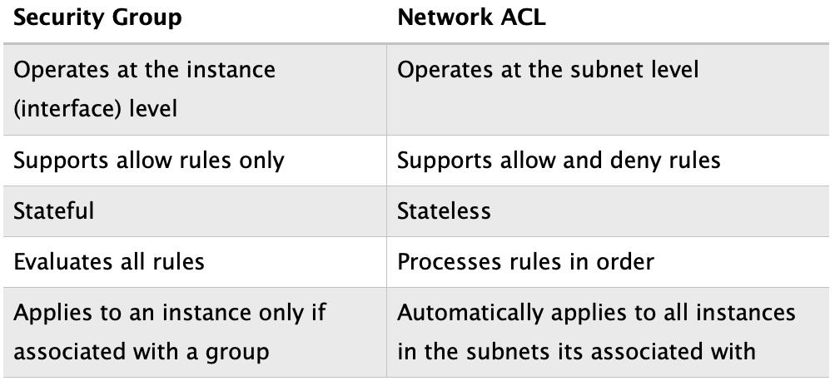

* **AWS AppSync** enables the creation of flexible APIs, including options for real-time updates and offline functionalities.
* **AWS Amplify** is a set of tools and services that can be used to build scalable full-stack apps powered by AWS, also supporting real-time functionalities and offline operations.
* **AWS AppConfig** is the correct answer because it allows users to deploy application configuration changes quickly and reliably without needing to write additional code or restart services. It supports validation checks to ensure configuration data is syntactically and semantically correct before deployment, avoiding potential outages.
* **Service Control Policies** are used in AWS Organizations to restrict available permissions. They do not grant permissions.
* **IAM Group** can be used for assigning permissions to multiple users.
* **Amazon Redshift** and **Amazon DynamoDB** can be reserved to avail maximum discounts
* **VPC Flow Logs** capture information about the IP traffic going to and from network interfaces in your VPC.
* With **AWS Snowmobile** you can move 100PB per snowmobile. AWS call this an “Exabyte-scale data transfer service
* An access key ID and secret access key are used to sign programmatic requests to AWS. They are associated with an IAM user.
* **AWS Transit Gateway** connects your Amazon Virtual Private Clouds (VPCs) and on-premises networks through a central hub. This simplifies your network and puts an end to complex peering relationships. It acts as a cloud router – each new connection is only made once.